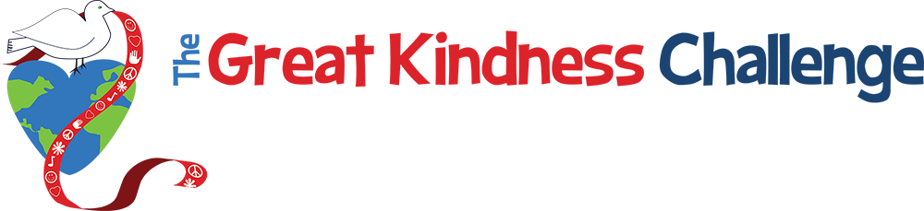
Suggested Reading List for Students

A Home For Bird by Phillip Stead
A Sick Day for Amos McGee by Phillip Stead
Angelo by David Macauley
Because Amelia Smiled by David Ezra Stein
Each Kindness by Jacqueline Woodson
Fill a Bucket by Carol McCloud
Fly Free! by Roseanne Thong
Good People Everywhere by Linea Gillen
Have You Filled Your Bucket Today? by Carol McCloud
Hey Little Ant by Phillip Hoose
How Dinosaurs Play With Their Friends by Jane Yolen
How Kind by Mary Murphy
I See Kindness Everywhere by by Shelley Frost
I’m Gonna Like Me by Jamie Lee Curtis
If You Give a Mouse a Cookie by Laura Joffe Numeroff
Kindness Is Cooler by Mrs. Ruler by Margorie Cuyler
Let’s Talk about Being Helpful by Joy Berry
Little Bird by Germano Zullo
Loser by Jerry Spinelli
Mufaro’s Beautiful Daughters by John Steptoe
Ordinary Mary’s Extraordinary Deed by Emily Robinson and Fumi Kosaka
Pauline Pastrami Achieves World Peace by James Proimos
Pinduli by Janell Cannon
Rainbow Fish by Marcus Pfister
Random Acts of Kindness by Conari Press
Somebody Loves Mr. Hatch by Eileen Spinelli
Spaghetti in a Hot Dog Bun: Having the Courage To Be Who You Are by Maria Dismondy
Stone Soup by Jon J.Muth
The Birdman by Veronika Charles
The Boy Who Held Back the Sea by Lenny Hort, Thomas Locker, and Mary Mapes Dodge
The Brand New Kid by Katie Couric
The Doorbell Rang by Pat Hutchins
The English Roses by Madonna
The Girl, the Fish and the Crown by Marilee Heyer
The Golden Rule by Ilene Cooper
The Great Kapok Tree by Lynn Cherry
The Hundred Dresses by Eleanor Estes
The Invisible Boy by Tracy Ludwig
The Kindness Quilt by Nancy Elizabeth Wallace
The Lion and the Mouse by Jerry Pinkney
The Little Engine that Could by Watty Piper
The Nice Book by David Ezra Stein
The Trumpet of the Swan by E. B. White
Those Shoes by Maribeth Boelts
Three Strong Women by Claus Stamm
Under The Lemon Moon by Edith Fine and Rene Moreno
Wonder by R.J. Palacio

